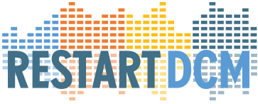

If you are unable to attend all live sessions, there is the option to receive a link to the recording for a maximum of 3 sessions. This link can be used up to two weeks after the session. To receive this link, submit this signed statement after which you will receive the link for the specific recording.

The link to the recording of the session of the Workshop RESTART-DCM on ______ (dd)

_____ (mm) - 2025 will be send to you as soon as you return this signed statement.

Regarding the video-recording of the workshop _______ (dd) - ______ (mm) - 2025 , I declare the following:

- this recording is for my private use only, I will **NOT** share this recording with anyone else

- I will **NOT** make any copies of this recording

- this recording is to be used for a 1-time (single) viewing

- I understand that I will have 2 weeks to watch the content of the video-recording after I have received the link. After 2 weeks the recording will be deleted.

- after viewing the recording, I will make sure that the video-recording is deleted from all my devices.

Signature: Place: Date:

_______________________ __________________ __________

Name: